# **EDUNET FOUNDATION-Class Exercise Notebook**

Lab 2 – Getting started with the GitHub

1. Register / Signin yourself on Github.

Click on the link below.

[GitHub: Where the world builds software · GitHub](https://github.com/)

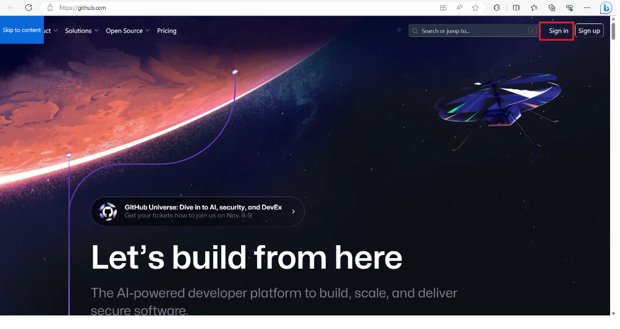

Click on the Sign In options. If don’t have the account then click on sign up, fill the details and get password and again go back to sign in page.

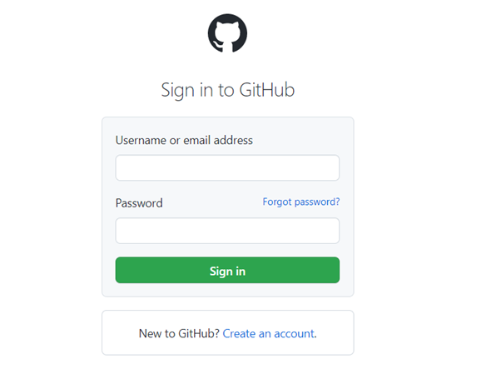

2. Click on the new repository

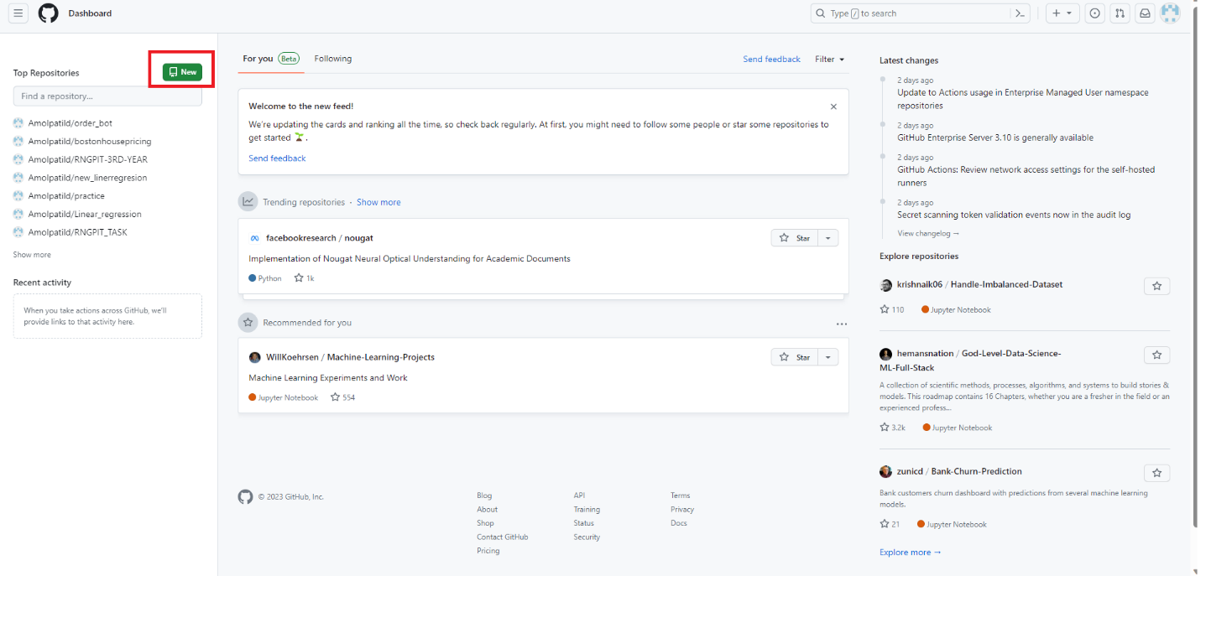

1. Create a new repository

Enter the name of the repository, then select the Public or Private, check the Add a READMI file and Click on the **Create repository.**

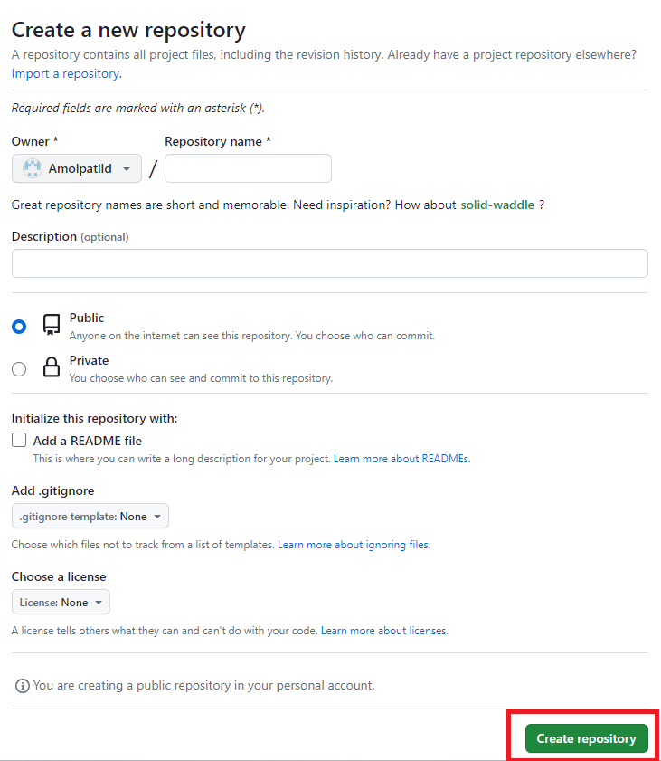

Now your screen will display like this.

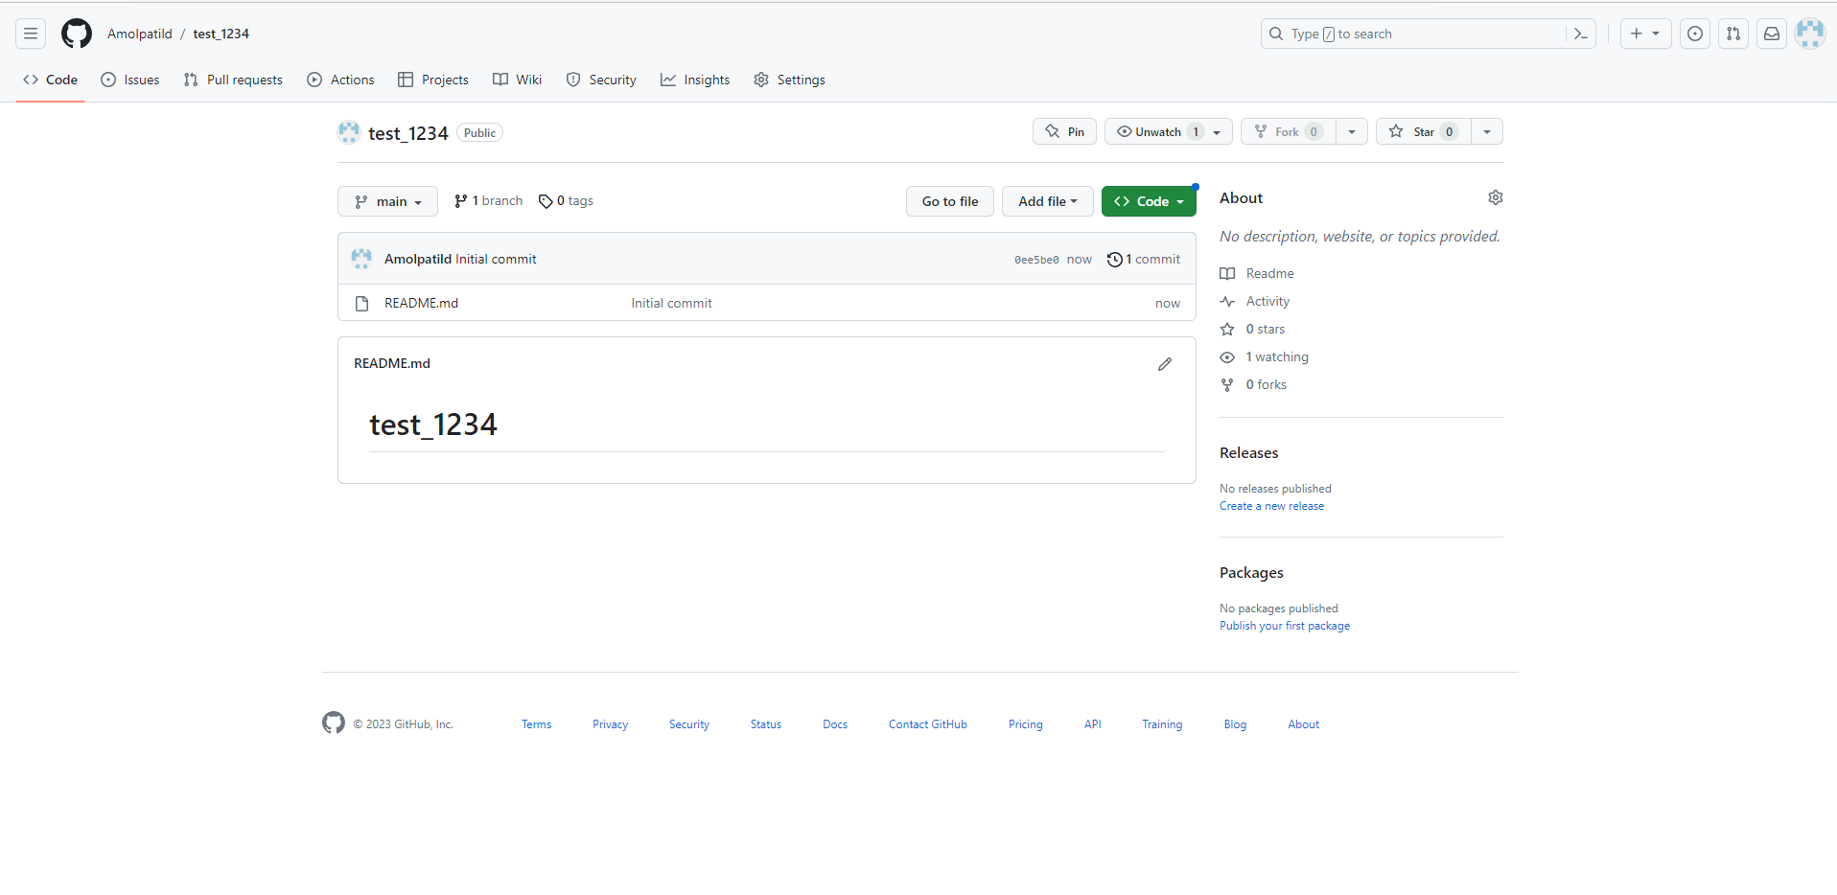

To add the files, you should have basic understanding of the git commands.

Let’s discuss this in next Lab.

1. Open Anaconda Command Prompt and install git library

pip install git

1. Create a directory with two random .txt files. Place any piece of text in those files.

Configure the access of github profile on local github library

git config --global user.name username

git config --global user.email useremail

** Place your github login username and email information.

1. Change the folder to as current working directory. And run git init code

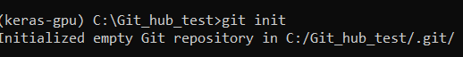

1. Git status shows files are untracked

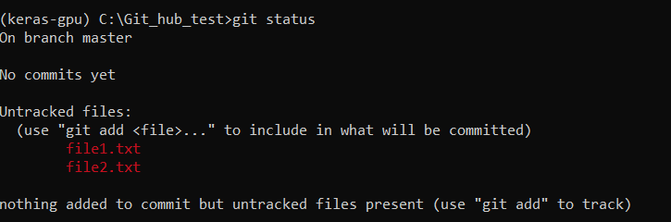

1. Add file1.txt to stage and check git status

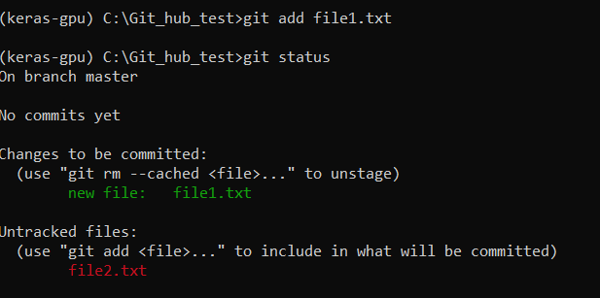

1. Now add another file2.txt to staging stage and check git status

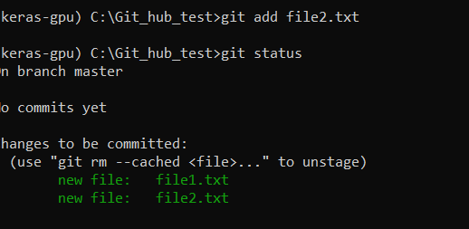

1. Commit the traced file using git commit command. You can also mention the commit message.

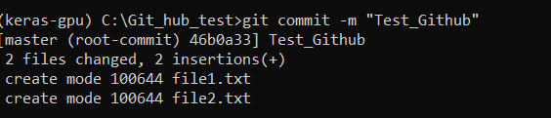

1. Add the address of repository to where you test files are to be uploaded.

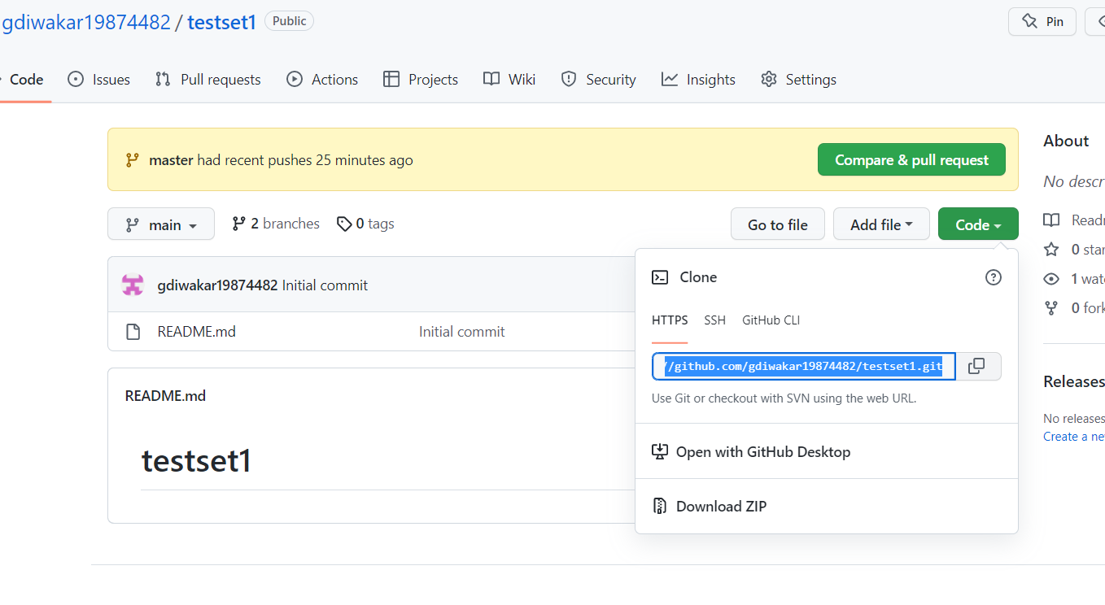



1. Upload your local repository to github using git push command

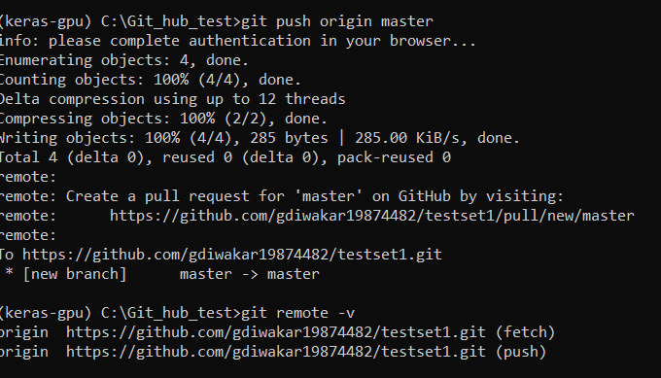

**Note: GUI window will request for read/ write access.

1. You will observe and conclude that your local repository gets uploaded to github repository

